Revisi Fitur Pelanggaran Dihapus --- template/sidebar.php

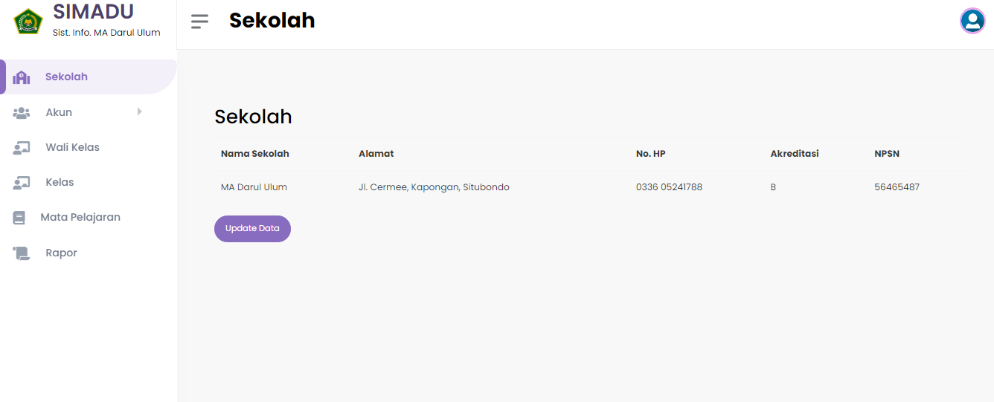

Revisi Output Rapor ->

Rapor_print_data.php -> ubah logo

Rapor_download_data.php -> for downloading file

Delete animasi preloader : template/header.php